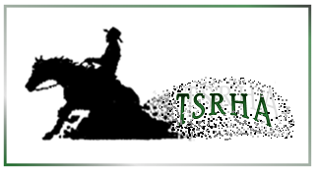
2024 Tri-State Reining Horse Association Membership Application

Please complete all information. Tab through fields (you may need to “Enable Editing” if downloading the form)

NAME - |  | NRHA# enter text
ADDRESS -
CITY - | STATE - | ZIP -
TELEPHONE - | E-MAIL -
(For checkboxes below, click on the box to select)
CHECK ONE: | ☐ ADULT | $25
 | ☐ YOUTH(as per NRHA rules) | $15
PAYMENT TYPE: | ☐ CASH | ☐ CHECK # -
TODAYS DATE -

-Check payable to TSRHA
-One Form per person

Mail form and payment to:
TSRHA
Kelly Bricker
262 Spithaler School Rd.
Evans City, PA 16033

Membership payment must be received before showing, for monies/points earned to count toward year-end qualification.

