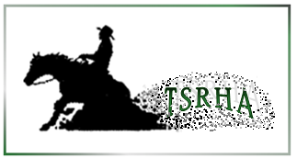
2026 Tri-State Reining Horse Association Membership Application

Please complete all information by tabbing through fields (you may need to “Enable Editing”)
One Form per person
NAME - |  | NRHA#
ADDRESS
CITY | STATE | ZIP
TELEPHONE | E-MAIL
(For checkboxes below, click on the box to select)
CHECK ONE: | ☐ ADULT | $40 (pd before 4/1/26) $45
 | ☐ YOUTH | $15
PAYMENT OPTIONS: Mark payment type below
- Pay with PayPal: @Tri-State RHA
E-mail the form to tsrhamail@gmail.com or mail it

- A&M Website: Complete form and payment on-line

- Send a check, made payable to TSRHA with this form

PAYMENT TYPE: ☐ PayPal | ☐ A&M Show App | ☐ CHECK # -
☐ CASH
TODAY'S DATE -

Mailing Address:
TSRHA
Kelly Bricker
262 Spithaler School Rd.
Evans City, PA 16033

Qualification for Year-End Awards:
1. Membership payment must be completed before showing for monies/points earned, to count toward year-end awards.
2. All owners and the rider must be members to be eligible.
3. Must show in at least 50% of the classes for the year (example: class offered 6x at 3 shows in the 2026 show season, must show in the class at least 3x).

